AI Assisted Coding Lab 9.4
Name: A.Yashwanth
2303A52432
Batch:42
Task 1: Auto-Generating Function Documentation in a Shared
Codebase
Scenario:
You have joined a development team where several utility functions are already implemented, but the code lacks proper documentation. New team members are struggling to understand how these functions should be used.
Prompt : Generate Google-style docstrings with Args, Returns
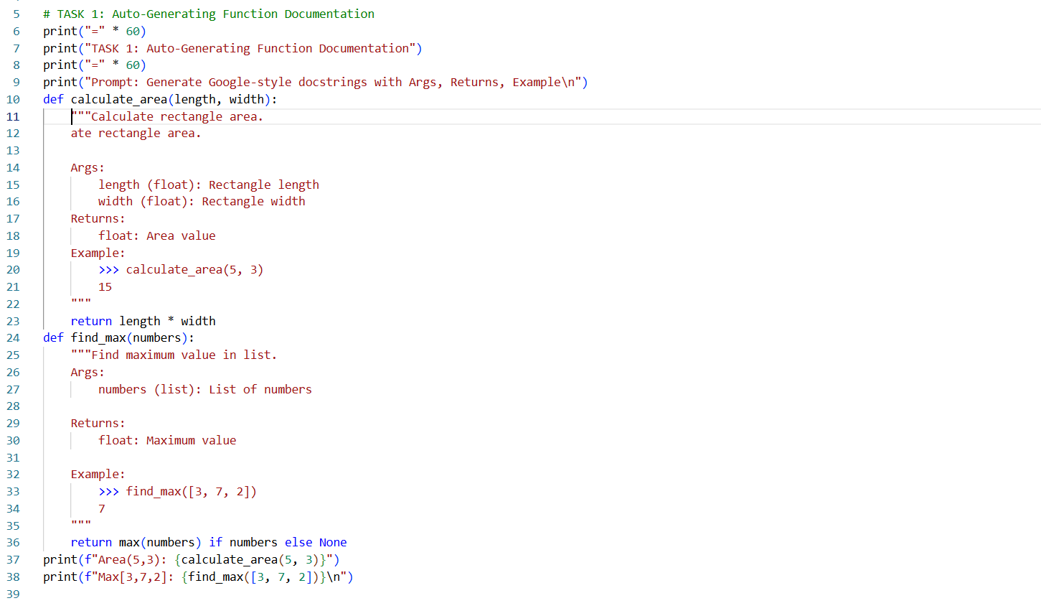
OUTPUT: 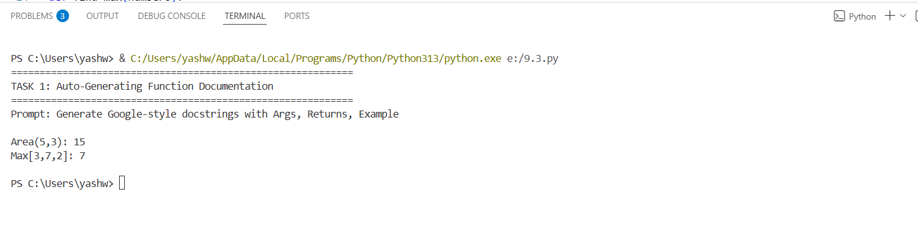
Task 2: Enhancing Readability Through AI-Generated Inline Comments
Scenario:
A Python program contains complex logic that works correctly but is
difficult to understand at first glance. Future maintainers may find it hard
to debug or extend this code.
Prompt: Add inline comments for complex logic
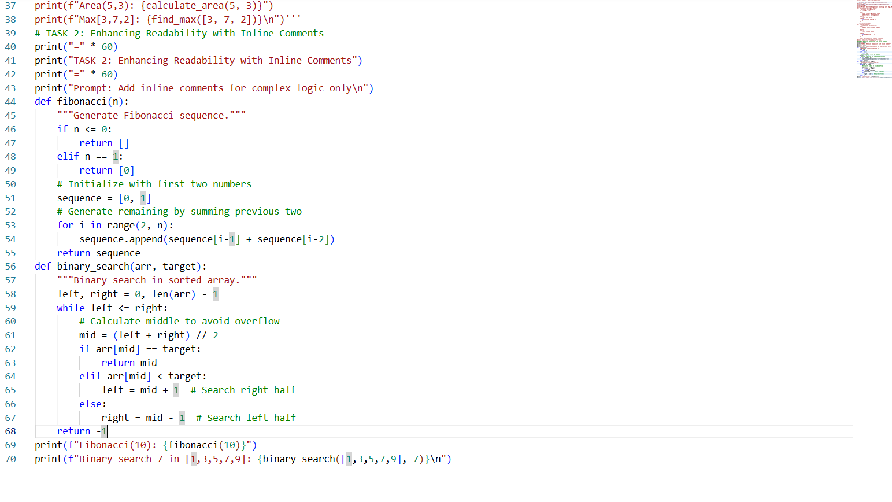
OUTPUT:
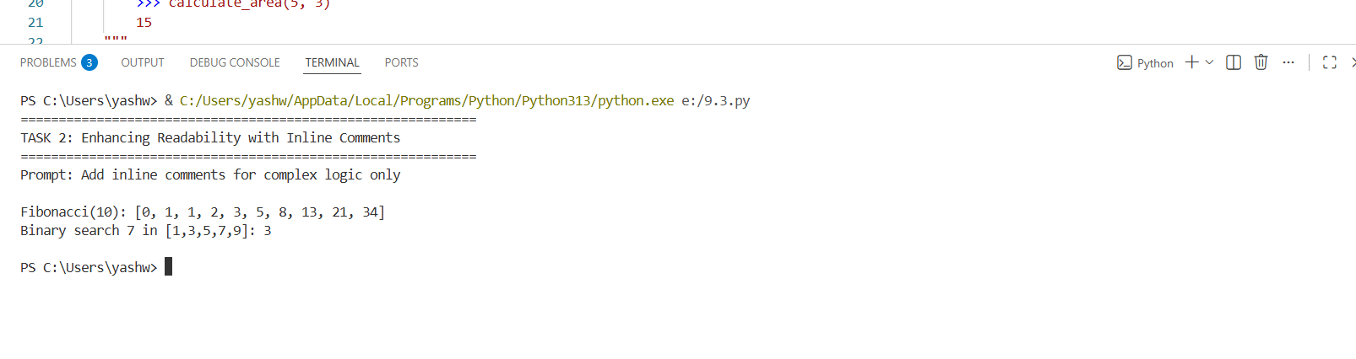
Task 3: Generating Module-Level Documentation for a Python
Package
Scenario:
Your team is preparing a Python module to be shared internally (or uploaded to a repository). Anyone opening the file should immediately understand its purpose and structure
Prompt: Generate comprehensive module docstring
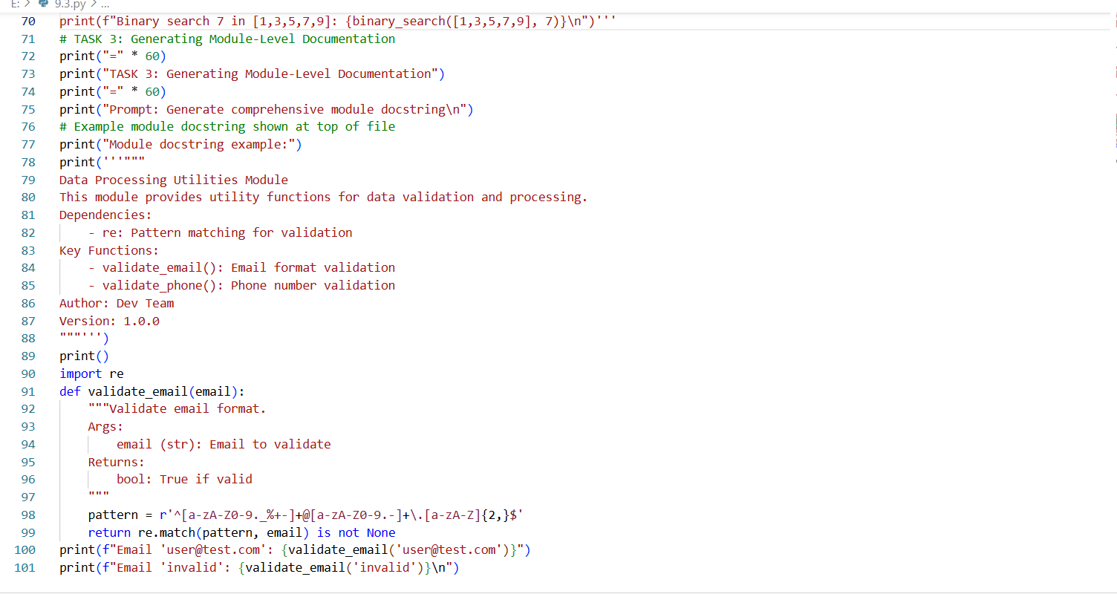
OUTPUT:
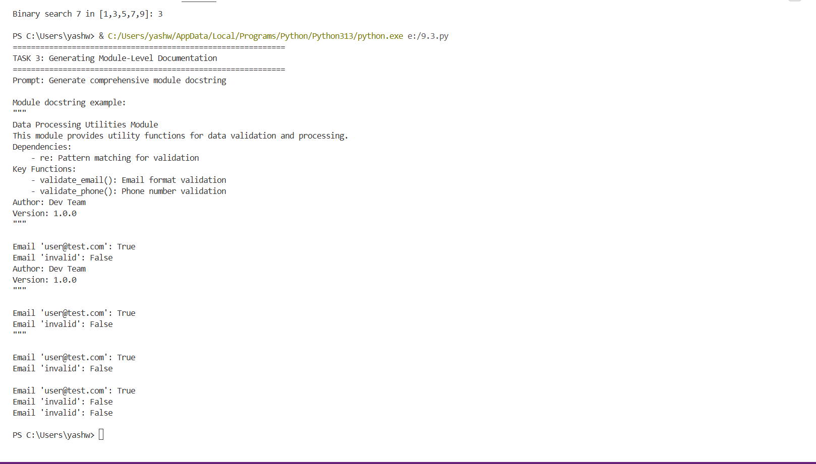
Task 4: Converting Developer Comments into Structured Docstrings
Scenario:
In a legacy project, developers have written long explanatory comments inside functions instead of proper docstrings. The team now wants to standardize documentation.
Prompt: Convert inline comments to Google-style docstrings
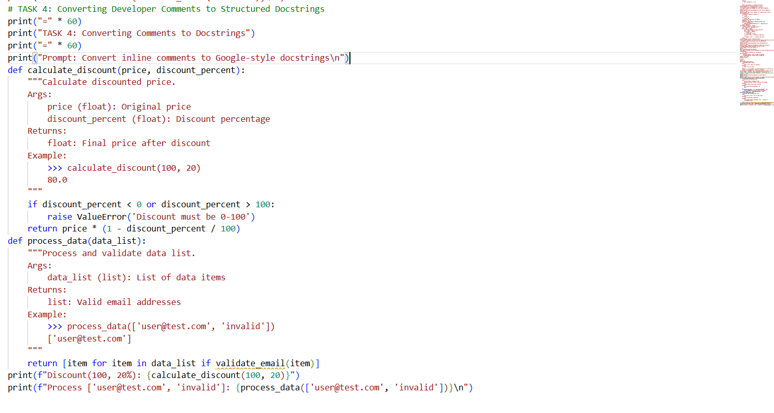
OUTPUT:
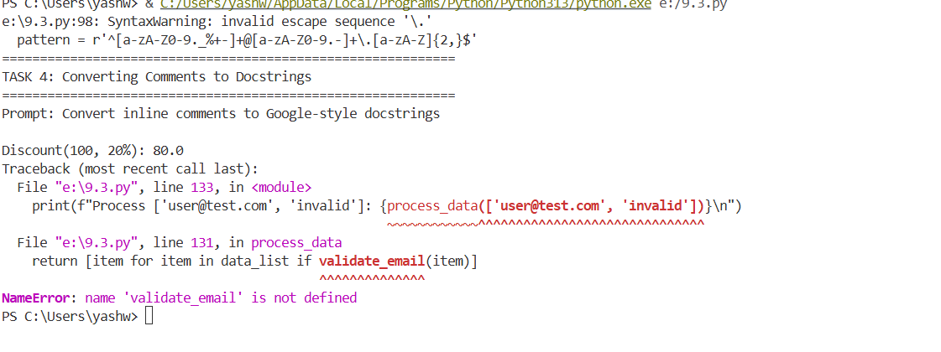
Task 5: Building a Mini Automatic Documentation Generator
Scenario:
Your team wants a simple internal tool that helps developers start documenting new Python files quickly, without writing documentation from scratch.
Pompt: Create utility using AST to detect missing docstrings
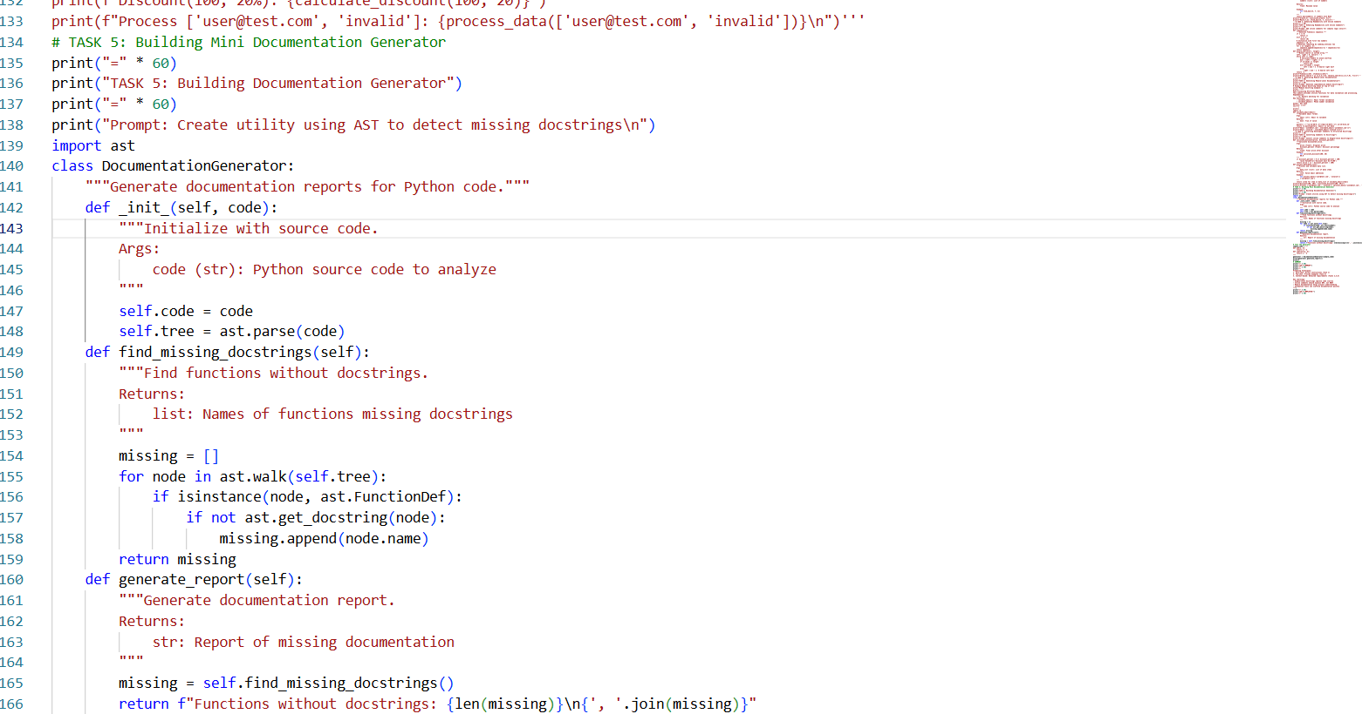
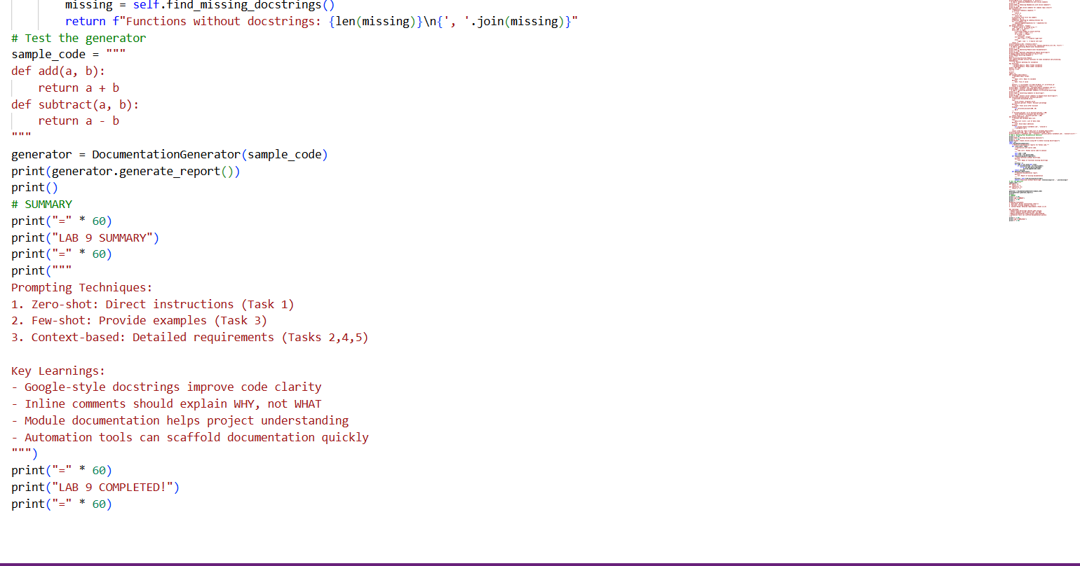
OUTPUT:
